The purpose of this lab is to practice using for loops that change value to draw a checkerboard on a sketch that is 640 x 640. We will do this in steps.

**Step 1:** Draw a row of squares with the same color. Pick your favorite color and use a single for loop to draw 8 squares across the top of the screen. Make sure the body of your for loop contains two lines of code: One for the for the color and one to draw the square.

**Step 2:** Repeat Step 1 seven more times changing the y coordinate so that each row is below the row above it. When you are done you should have a sketch that is similar to this:

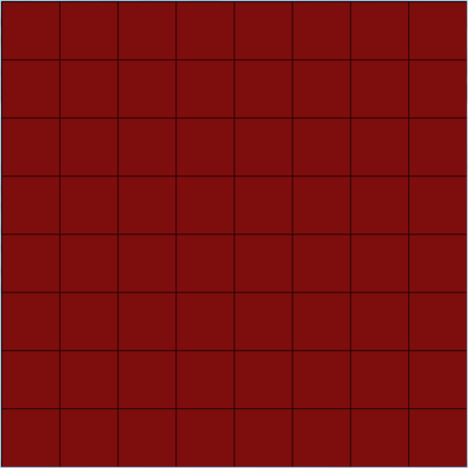

**Step 3:** Add a variable at the top called count. Set count to 0 in your setup() method. Add a line in the body of each of your for loops so that count will increase by one. Put this line at the end of the body.

**Step 4:** We want to alternate colors on our board which means we need to select between our original color and a second option. Our variable named count will help us decide. We will be checking to see if count is even or odd. To do this with the computer, we have to use the proper control structure and some clever math because the computer does not understand “even” or “odd.” However, it can give us the remainder of a number which is useful. For example, 13 % 2 is 1, 28 % 5 is 3, and 8 % 2 is 0. In your control structure, check to see if count is even (remember % by 2 and check to see if it is 0). If it is, select your original color, otherwise select a second color of your choice. Try this on one row before adding the code to all of your for loops. When you are finished you should have a final product that looks like this:

